UCS 1611 - Internet Programming Lab **Exercise 1:** Website for International Conference Using HTML5 Tags

**Swetha Saseendran**

**CSE-C**

**185001183**

**Learning objective:**

To develop a Website for an International Conference using HTML5 elements with the following specifications:-

* The conference homepage should consists of the following tabs: Home, Committee, Call For Papers, Important Dates, Workshops, Registration and Contact.
* On clicking each tab, it should open in a separate page.
* The website should contain background Image, logos, header, footer.
* Use tooltip text for help.
* For pre-conference workshop registration use form elements.
* Mandatory Tags: List, Table, Anchor, Image, Semantic Tags.

**Code- Home Page:**

<!DOCTYPE html>

<html>

<head>

<title>International Conference</title>

<link rel="stylesheet" href="https://cdnjs.cloudflare.com/ajax/libs/font-awesome/4.7.0/css/font-awesome.min.css">

<link rel="icon" href="fav.png" sizes="32x32">

</head>

<body>

<nav style="background-color: #334467; overflow: hidden;">

<a href="index.html" target=”_blank” style="float: left; display: block; text-align: center;padding: 14px 16px; font-size: 17px; text-decoration: none;background-color: #534caf;color: white;">Home</a>

<a href="commitee.html" target=”_blank” style="float: left; display: block;color: #f2f2f2; text-align: center;padding: 14px 16px; font-size: 17px; text-decoration: none;">Commitee</a>

<a href="call.html" target=”_blank” style="float: left; display: block;color: #f2f2f2; text-align: center;padding: 14px 16px; font-size: 17px; text-decoration: none;">Call For Papers</a>

<a href="imp.html" target=”_blank” style="float: left; display: block;color: #f2f2f2; text-align: center;padding: 14px 16px; font-size: 17px; text-decoration: none;">Important Dates</a>

<a href="workshop.html" target=”_blank” style="float: left; display: block;color: #f2f2f2; text-align: center;padding: 14px 16px; font-size: 17px; text-decoration: none;">Workshops</a>

<a href="registration.html" target=”_blank” style="float: left; display: block;color: #f2f2f2; text-align: center;padding: 14px 16px; font-size: 17px; text-decoration: none;">Register</a>

<a href="contact.html" target=”_blank” style="float: left; display: block;color: #f2f2f2; text-align: center;padding: 14px 16px; font-size: 17px; text-decoration: none;">Contact Us</a>

</nav>

<header>

<img src="header.PNG" style="width: 100%; height: 200px;">

</header>

<marquee> <h3 style="color:rgb(127, 127, 206);"> The conference footer would appear on all pages. The text is as follows, on a single centred line: 2019 International Conference on Indoor Positioning and Indoor Navigation (IPIN), 30 Sept. - 3 Oct. 2019, Pisa, Italy</h3></marquee>

<div style="margin: 40px; margin-left: 55px;">

<h1 style="color:rgb(127, 127, 206);">ABOUT US</h1>

</div>

<article style="background-color:#f1f1f1;padding: 50px;"

<section>

<p>International Conference Alerts provides details about the upcoming academic conferences, seminars and workshops to be held worldwide. Academician and professionals can get their relevant updates and conference alerts through International conference alerts. International Conference Alerts provides a free subscription to its users with email notifications about upcoming Medical conferences, Engineering conferences, Business and Economics, Science and education and various conferences. Users can register and subscribe to get free conference alerts regarding upcoming international conferences 2021 at Dubai, Germany, Singapore, Thailand, USA as well as all major cities and countries across the world. This is the exact reason why internationalconferencealerts.com was established - to provide the masses, up-to-date and incredibly reliable information on all upcoming conferences, in a variety of fields.</p>

</section>

<section>

<p>Many prominent and successful researchers, scientists and scholars have attributed their success to international conferences that they attended early on in their careers. They cited the great learning, networking, and collaborative opportunities that these conferences present, as being the reason for their success. International Conference Alerts offers conference organizers/planners the provision to better target potential conference delegates by allowing them to add details about their upcoming events to our existing conference listings. Numerous conference organizers and planners have witnessed remarkable growth in attendance at their events, after posting information about these events on our website! So take advantage of these provisions and expand your career or learn more about the latest developments in your field, today.</p>

</section>

</article>

<footer style="background-color: #08202e; padding-top: 35px; padding-bottom: 35px;font-weight: 400;font-size: 17px;">

<p align ="center" style="color: white;"> © Copyright All Rights Reserved 2021 | <a href="#" style="color: cornflowerblue;">Terms **&amp;** Conditions</a></p>

<div style="margin-left:560px; background-color: white; width: fit-content;">

<a href="#" class="facebook"><i class="fa fa-facebook"></i></a>

<a href="#" class="twitter"><i class="fa fa-twitter"></i></a>

<a href="#" class="google"><i class="fa fa-google"></i></a>

<a href="#" class="linkedin"><i class="fa fa-linkedin"></i></a>

<a href="#" class="youtube"><i class="fa fa-youtube"></i></a>

</div>

</footer>

</body>

</html>

**Code- Committee Page:**

<html>

<head>

<title>International Conference</title>

<link rel="icon" href="fav.png" sizes="32x32">

</head>

<body>

<nav style="background-color: #334467; overflow: hidden;">

<a href="index.html" style="float: left; display: block;color: #f2f2f2; text-align: center;padding: 14px 16px; font-size: 17px; text-decoration: none;">Home</a>

<a href="commitee.html" target=”_blank” style="float: left; display: block; text-align: center;padding: 14px 16px; font-size: 17px; text-decoration: none;background-color: #534caf;color: white;">Commitee</a>

<a href="call.html" target=”_blank” style="float: left; display: block;color: #f2f2f2; text-align: center;padding: 14px 16px; font-size: 17px; text-decoration: none;">Call For Papers</a>

<a href="imp.html" target=”_blank” style="float: left; display: block;color: #f2f2f2; text-align: center;padding: 14px 16px; font-size: 17px; text-decoration: none;">Important Dates</a>

<a href="workshop.html" target=”_blank” style="float: left; display: block;color: #f2f2f2; text-align: center;padding: 14px 16px; font-size: 17px; text-decoration: none;">Workshops</a>

<a href="registration.html" target=”_blank” style="float: left; display: block;color: #f2f2f2; text-align: center;padding: 14px 16px; font-size: 17px; text-decoration: none;">Register</a>

<a href="contact.html" target=”_blank” style="float: left; display: block;color: #f2f2f2; text-align: center;padding: 14px 16px; font-size: 17px; text-decoration: none;">Contact Us</a>

</nav>

<header>

<img src="header.PNG" style="width: 100%; height: 200px;">

</header>

<div style="margin: 40px; margin-left: 55px;">

<h1 style="color:rgb(76, 76, 207);">International Conference Committees</h1>

</div>

<div style="background-color:#f1f1f1;padding: 50px;">

<ol>

<li>DLT 2010 - Developments on Language Theory, London, Ontario, 2010 - Organizing Committee Member.</li>

<li>DNA Computing 15 - 15th International Conference on DNA Computing, University of Arkansas, U.S.A., June 2009 - Program Committee Member.</li>

<li>UC 2009 - 8th International Conference on Unconventional Computation - Program Committee Member.</li>

<li>9th Workshop on Membrane Computing, Heriot-Watt University, July 28-31, 2008 - Program Committee Member, 2008.</li>

<li>"Descriptional Complexity of Formal Systems" (DCFS'08), Prince Edward Island, Canada July 16-18, 2008 - Program Committee Member.</li>

<li>SIAM Meeting on Discrete Mathematics, University of Vermont, June 16-19, 2008 - Organizing Committee Member.</li>

<li>Developments in Language Theory, DLT 2006, Santa Barbara, California, June 2006 - Program Committee Member.</li>

<li>Transgressive Computing, Granada, April 2006 - Program Committee Member.</li>

<li>Descriptional Complexity of Formal Systems, DCFS 2006, Las Cruces, New Mexico (USA), June 21-23, 2006 - Program Committee Member.</li>

<li>12th International Meeting on DNA Computing (DNA12), Seoul, Korea, June 2006 - Program Committee Member.</li>

<li>11th International Meeting on DNA Computing (DNA11), London, June 2005 - Organizing Committee Chair.</li>

<li>10th International Meeting on DNA Computing (DNA10), Milano, Italy, June 2004 - Program Committee Member.</li>

<li>Descriptional Complexity of Formal Systems, DCFS 2004 - Program Committee Member.</li>

<li>Genetic and Evolutionary Computation Conference, GECCO-2002, New York, July 2002 - Program Committee Member.</li>

<li>8th International Meeting on DNA-Based Computers (DNA8), Sapporo, Japan, June 2002 - Program Committee Member.</li>

<li>Fifth International Conference Developments in Language Theory, DLT 2001, Wien Austria, July 16-21, 2001 - Program Committee Member.</li>

<li>Congress on Evolutionary Computation (CEC2001) Seoul, Korea, May 27-30, 2001 - Organizing Committee Member.</li>

<li>7th International Meeting on DNA-Based Computers (DNA7), June 2001, Tampa, Florida - Program Committee Member.</li>

<li>SPIRE'2000 - String Processing and Information REtrieval, September 27 - 29, 2000, A Coruna, Spain - Program Committee Member.</li>

<li>Molecular Computing Session, Congress on Evolutionary Computation, San Diego USA, 16-19 July 2000 - Technical Committee Member.</li>

<li>Mathematical Foundations of Computer Science, MFCS 2000, Bratislava, Slovakia - Program Committee Member.</li>

<li>6th International Meeting on DNA Based Computers (DNA6), Leiden, The Netherlands, June 13-16, 2000 - International Organizing Committee Member.</li>

<li>Fifth International Conference on Implementation and Application of Automata (CIAA'2000), London, Ontario, Canada, Summer 2000 - Organizing Committee Member.</li>

<li>Half Century of Automata Theory. London, Ontario, Canada, Summer 2000 - Organizing Committee Member.</li>

<li>Descriptional Complexity of Automata, Grammars and Related Structures. London, Ontario, Canada, Summer 2000 - Organizing Committee Member.</li>

<li>6th Symposium on String Processing and Information Retrieval, SPIRE 1999, Cancun, Mexico, September 1999 - Program Committee Member.</li>

<li>5th International Meeting on DNA-Based Computers (DNA5), M.I.T. Boston, June 1999 - Program Committee Member.</li>

<li>Workshop on Molecular Computing at MFCS'98 (Mathematical Foundations of Computer Science 1998, Brno, Czech Republic, August 1998 - Program Committee Member.</li>

<li>Mini-symposium on DNA computing sponsored by the Society for Mathematical Biology in conjunction with the SIAM annual meeting Toronto, Canada, July 13-17, 1998 - Organizer.</li>

<li>4th International Meeting on DNA-Based Computers (DNA4), Philadelphia, June 1998 - Program Committee Chair.</li>

</ol>

</div>

<footer style="background-color: #08202e; padding-top: 35px; padding-bottom: 35px;font-weight: 400;font-size: 17px;">

<p align ="center" style="color: white;"> © Copyright All Rights Reserved 2021 | <a href="#" style="color: cornflowerblue;">Terms **&amp;** Conditions</a></p>

</footer>

</body>

</html>

**Code- Call for Papers Page:**

<html>

<head>

<title>International Conference</title>

<link href="style.css" rel="stylesheet" type="text/css" />

<link rel="icon" href="fav.png" sizes="32x32">

</head>

<body>

<nav style="background-color: #334467; overflow: hidden;">

<a href="index.html" target=”_blank” style="float: left; display: block;color: #f2f2f2; text-align: center;padding: 14px 16px; font-size: 17px; text-decoration: none;">Home</a>

<a href="commitee.html" target=”_blank” style="float: left; display: block;color: #f2f2f2; text-align: center;padding: 14px 16px; font-size: 17px; text-decoration: none;">Commitee</a>

<a href="call.html" target=”_blank” style="float: left; display: block; text-align: center;padding: 14px 16px; font-size: 17px; text-decoration: none;background-color: #534caf;color: white;">Call For Papers</a>

<a href="imp.html" target=”_blank” style="float: left; display: block;color: #f2f2f2; text-align: center;padding: 14px 16px; font-size: 17px; text-decoration: none;">Important Dates</a>

<a href="workshop.html" target=”_blank” style="float: left; display: block;color: #f2f2f2; text-align: center;padding: 14px 16px; font-size: 17px; text-decoration: none;">Workshops</a>

<a href="registration.html" target=”_blank” style="float: left; display: block;color: #f2f2f2; text-align: center;padding: 14px 16px; font-size: 17px; text-decoration: none;">Register</a>

</nav>

<header>

<img src="header.PNG" style="width: 100%; height: 200px;">

</header>

<div style="margin: 40px; margin-left: 55px;">

<h1 style="color:rgb(76, 76, 207);">Conference Call for Papers</h1>

</div>

<article>

<section style="background-color:#f1f1f1;padding: 50px;"

<p>The 3rd International Conference on Advanced Research in Social Sciences (ICARSS), March 11 – 14, 2021 in Oxford, United Kingdom, is the premier forum for the presentation of new advances and research results in education theory and practice.</p>

<p>This conference is a prestigious event, organized to provide an international platform for the academicians, researchers, managers, industrial participants and students to share their research findings with global experts. All full paper submissions will be peer reviewed and evaluated based on originality, technical and/or research depth, accuracy and relevance to conference call for papers.</p>

<a style="color:rgb(76, 76, 207);"><em>Submission Format</em></a><br>

Authors must follow the Springer LNCS formatting instructions. For camera-ready papers use Latex or Word style (Author’s instruction page ). Each paper will receive at least three reviews. At least one author of each accepted paper must register by the early registration date indicated on the conference website and present the paper.

</section>

</article>

<article style="clear:both;background-color:#f1f1f1">

<section style="background-color:#f1f1f1;padding: 50px;">

<h2 style="background-color: #959adf; width:40%; padding:10px">Sociology</h2>

<ul>

<li>Aging</li>

<li>Applied Anthropology</li>

<li>Archaeology</li>

<li>Black Lives Matter</li>

<li>Elderly care</li>

<li>Child Research</li>

<li>Childhood Development & Schooling</li>

</ul>

</section>

<section style="margin: 30px;background-color:#f1f1f1;width: fit-content;padding-right:20px;">

<h2 style="background-color: #959adf; width:fit-content; padding:10px">Philosophy</h2>

<ul>

<li>Pragmatism</li>

<li>Realism</li>

<li>Romanticism</li>

<li>Social Philosophy</li>

<li>Transcendentalism</li>

<li>Utilitarianism</li>

<li>Western Philosophy</li>

</ul>

</section>

<br>

</article>

<article style="clear:both;background-color:#f1f1f1">

<section style="margin: 30px;background-color:#f1f1f1;width: fit-content;padding-right:20px;">

<h2 style="background-color: #959adf; width:fit-content; padding:10px">Politics</h2>

<ul>

<li>Congressional Review Act</li>

<li>Debates</li>

<li>Democracy and Democratization</li>

<li>Donald Trump</li>

<li>Environmental Protection Agency</li>

<li>Executive power</li>

<li>Facebook campaigning</li>

<li>Governmental Systems & Practices</li>

</ul>

</section>

<section style="margin: 30px;background-color:#f1f1f1;width: fit-content;padding-right:20px;">

<h2 style="background-color:#959adf; width:fit-content; padding:10px">Law</h2>

<ul>

<li>Forensic genealogy</li>

<li>Fraud</li>

<li>Geneva Conventions</li>

<li>Hate crime</li>

<li>Hate groups</li>

<li>Identity theft</li>

<li>Illegal drug use</li>

<li>International Human Right Law</li>

</ul>

</section>

<br>

</article>

<br><br>

<footer style="background-color: #08202e; padding-top: 35px; padding-bottom: 35px;font-weight: 400;font-size: 17px;">

<p align ="center" style="color: white;"> © Copyright All Rights Reserved 2021 | <a href="#" style="color: cornflowerblue;">Terms **&amp;** Conditions</a></p>

</footer>

</body>

</html>

**Code- Important Dates**

<html>

<head>

<title>International Conference</title>

<link href="style.css" rel="stylesheet" type="text/css" />

<link rel="icon" href="fav.png" sizes="32x32">

</head>

<body>

<nav style="background-color: #334467; overflow: hidden;">

<a href="index.html" style="float: left; display: block;color: #f2f2f2; text-align: center;padding: 14px 16px; font-size: 17px; text-decoration: none;">Home</a>

<a href="commitee.html" target=”_blank” style="float: left; display: block;color: #f2f2f2; text-align: center;padding: 14px 16px; font-size: 17px; text-decoration: none;">Commitee</a>

<a href="call.html" target=”_blank” style="float: left; display: block;color: #f2f2f2; text-align: center;padding: 14px 16px; font-size: 17px; text-decoration: none;">Call For Papers</a>

<a href="imp.html" target=”_blank” style="float: left; display: block; text-align: center;padding: 14px 16px; font-size: 17px; text-decoration: none;background-color: #534caf;color: white;">Important Dates</a>

<a href="workshop.html" target=”_blank” style="float: left; display: block;color: #f2f2f2; text-align: center;padding: 14px 16px; font-size: 17px; text-decoration: none;">Workshops</a>

<a href="registration.html" target=”_blank” style="float: left; display: block;color: #f2f2f2; text-align: center;padding: 14px 16px; font-size: 17px; text-decoration: none;">Register</a>

<a href="contact.html" target=”_blank” style="float: left; display: block;color: #f2f2f2; text-align: center;padding: 14px 16px; font-size: 17px; text-decoration: none;">Contact Us</a>

</nav>

<header>

<img src="header.PNG" style="width: 100%; height: 200px;">

</header>

<div style="margin: 40px; margin-left: 55px;">

<h1 style="color:rgb(76, 76, 207);">DATES OF IMPORTANCE</h1>

</div>

<article style="background-color:#f1f1f1;padding: 50px;">

<table style="height: 191px; width: 428px; border:1px solid black;">

<tr>

<td style="width: 201px; padding-left: 30px; border:1px solid black;">Paper Submission Opens</td>

<td style="width: 223px; padding-left: 30px; border:1px solid black;"><strong>December 01, 2020</strong></td>

</tr>

<tr style="padding-left: 30px;">

<td style="width: 201px; padding-left: 30px; border:1px solid black;">Paper Submission Closes:</td>

<td style="width: 223px; padding-left: 30px; border:1px solid black;">

<strong>January 31, 2021</strong></p>

</td>

</tr>

<tr style="padding-left: 30px;">

<td style="width: 201px; padding-left: 30px; border:1px solid black;">Acceptance Notification</td>

<td style="width: 223px; padding-left: 30px; border:1px solid black;"><strong>February 15, 2021</strong></td>

</tr>

<tr style="padding-left: 30px;">

<td style="width: 201px; padding-left: 30px; border:1px solid black;">Camera Ready Submission**&nbsp;**</td>

<td style="width: 223px; padding-left: 30px; border:1px solid black;"><strong>March 10, 2021(including registration of authors and payments)</strong></td>

</tr>

<tr style="padding-left: 30px;">

<td style="width: 201px; padding-left: 30px; border:1px solid black;">Pre Conference Workshop**&nbsp;**</td>

<td style="width: 223px; padding-left: 30px; border:1px solid black;"><strong>March 18, 2021</strong></td>

</tr>

<tr style="padding-left: 30px;">

<td style="width: 201px; padding-left: 30px; border:1px solid black;">Conference</td>

<td style="width: 223px; padding-left: 30px; border:1px solid black;"><strong>**&nbsp;**March 18,19 and 20, 2021</strong></td>

</tr>

</table>

</article>

<footer style="background-color: #08202e; padding-top: 35px; padding-bottom: 35px;font-weight: 400;font-size: 17px;">

<p align ="center" style="color: white;"> © Copyright All Rights Reserved 2021 | <a href="#" style="color: cornflowerblue;">Terms **&amp;** Conditions</a></p>

</footer>

</body>

</html>

**Code- Workshop:**

<!DOCTYPE html>

<html>

<head>

<title>International Conference</title>

</head>

<body>

<div style="background-color: #334467; overflow: hidden;">

<a href="index.html" target=”_blank” style="float: left; display: block;color: #f2f2f2; text-align: center;padding: 14px 16px; font-size: 17px; text-decoration: none;">Home</a>

<a href="commitee.html" target=”_blank” style="float: left; display: block;color: #f2f2f2; text-align: center;padding: 14px 16px; font-size: 17px; text-decoration: none;">Commitee</a>

<a href="call.html" target=”_blank” style="float: left; display: block;color: #f2f2f2; text-align: center;padding: 14px 16px; font-size: 17px; text-decoration: none;">Call For Papers</a>

<a href="imp.html" target=”_blank” style="float: left; display: block;color: #f2f2f2; text-align: center;padding: 14px 16px; font-size: 17px; text-decoration: none;">Important Dates</a>

<a href="workshop.html" target=”_blank” style="float: left; display: block; text-align: center;padding: 14px 16px; font-size: 17px; text-decoration: none;background-color: #534caf;color: white;">Workshops</a>

<a href="registration.html" target=”_blank” style="float: left; display: block;color: #f2f2f2; text-align: center;padding: 14px 16px; font-size: 17px; text-decoration: none;">Register</a>

<a href="contact.html" target=”_blank” style="float: left; display: block;color: #f2f2f2; text-align: center;padding: 14px 16px; font-size: 17px; text-decoration: none;">Contact Us</a>

</div>

<header>

<img src="header.PNG" style="width: 100%; height: 200px;">

</header>

<div style="margin: 40px; margin-left: 55px;">

<h1 style="color:rgb(127, 127, 206);">PRE-CONFERENCE WORKSHOPS</h1>

</div>

<article style="background-color:#f1f1f1;padding: 50px;">

<section style="display:table-cell; vertical-align:top; float:left;">

<h3>SUNDAY, 07 JUNE 2020 - ON-DEMAND</h3>

<ol>

<li>WS-01: Workshop on Integrating UAVs into 5G and Beyond</li>

<li>WS-02: Workshop on Convergent IoT (C-IoT)</li>

<li>WS-04: Workshop on 5G LTE and Intelligent Communications</li>

<li>WS-05: Workshop on V2X Technologies for Next Generation Driving Paradigm</li>

<li>WS-06: SecSDN: Secure and Dependable Software defined Networking for Sustainable Smart Communities</li>

</ol>

</section>

<div classstyle="display:table-cell;float:right;">

<img src="img.PNG" style="padding-left:20px;width:200px;height:200px;" />

</div>

<section style="display:table-cell; vertical-align:top; float:right;">

<h3>THURSDAY, 11 JUNE 2020 - ON-DEMAND</h3>

<ol>

<li>WS-01: Workshop on Integrating UAVs into 5G and Beyond</li>

<li>WS-02: Workshop on Convergent IoT (C-IoT)</li>

<li>WS-04: Workshop on 5G LTE and Intelligent Communications</li>

<li>WS-05: Workshop on V2X Technologies for Next Generation Driving Paradigm</li>

<li>WS-06: SecSDN: Secure and Dependable Software defined Networking for Sustainable Smart Communities</li>

</ol>

</section>

<div classstyle="display:table-cell;float:left;">

<img src="work.jpg" style="padding-left:20px;width:200px;height:200px;" />

</div>

</article>

<div style="background-color: #08202e; padding-top: 35px; padding-bottom: 35px;font-weight: 400;font-size: 17px;">

<p align ="center" style="color: white;"> © Copyright All Rights Reserved 2021 | <a href="#" style="color: cornflowerblue;">Terms **&amp;** Conditions</a></p>

</div>

</body>

</html>

**Code- Registration Page:**

<!DOCTYPE html>

<html>

<head>

<title>International Conference</title>

</head>

<body>

<nav style="background-color: #334467; overflow: hidden;">

<a href="index.html" target=”_blank” style="float: left; display: block;color: #f2f2f2; text-align: center;padding: 14px 16px; font-size: 17px; text-decoration: none;">Home</a>

<a href="commitee.html" target=”_blank” style="float: left; display: block;color: #f2f2f2; text-align: center;padding: 14px 16px; font-size: 17px; text-decoration: none;">Commitee</a>

<a href="call.html" target=”_blank” style="float: left; display: block;color: #f2f2f2; text-align: center;padding: 14px 16px; font-size: 17px; text-decoration: none;">Call For Papers</a>

<a href="imp.html" target=”_blank” style="float: left; display: block;color: #f2f2f2; text-align: center;padding: 14px 16px; font-size: 17px; text-decoration: none;">Important Dates</a>

<a href="workshop.html" target=”_blank” style="float: left; display: block;color: #f2f2f2; text-align: center;padding: 14px 16px; font-size: 17px; text-decoration: none;">Workshops</a>

<a href="registration.html" target=”_blank” style="float: left; display: block; text-align: center;padding: 14px 16px; font-size: 17px; text-decoration: none;background-color: #534caf;color: white;">Register</a>

<a href="contact.html" target=”_blank” style="float: left; display: block;color: #f2f2f2; text-align: center;padding: 14px 16px; font-size: 17px; text-decoration: none;">Contact Us</a>

</nav>

<header>

<img src="header.PNG" style="width: 100%; height: 200px;">

</header>

<div style="margin: 40px; margin-left: 55px;">

<h1 style="color:rgb(127, 127, 206);">Register Now!</h1>

</div>

<section style="margin: 30px;background-color:#f1f1f1;padding-top: 50px;padding-right: 30px;padding-bottom: 50px;padding-left: 80px;">

<p>

The registration fee for different categories of participants is mentioned in the table below. The registration fee for main conference with workshop will cover conference & workshop, full access to all sessions/invited talks including the pre-conference workshop.

</p>

<p>

Currently the only possible mode of payment is NEFT/RTGS for Indian participants and wire transfer for foreign participants. The required bank details are mentioned below:

</p>

<ul>

<li>Bank Account Holders Name :: The Principal SSN College of Engineering</li>

<li>Bank A/c Name (NEFT/RTGS/E-Payment) :: 158100050070022</li>

<li>Bank Name :: Tamilnad Mercantile Bank</li>

<li>IFSC/MICR Code :: TMBL0000158 / 600060010</li>

<li>Swift Code :: TMBLINBBCHE</li>

</ul>

</section>

<section style="margin: 30px;background-color:#f1f1f1;padding-top: 50px;padding-right: 30px;padding-bottom: 50px;padding-left: 80px;">

<h2><em>Register Here:</em></h2>

<form>

<label for="fname">First name:</label><br>

<input type="text" id="fname" name="fname"><br>

<label for="lname">Last name:</label><br>

<input type="text" id="lname" name="lname"><br>

<label for="email">Email:</label><br>

<input type="text" id="email" name="email">

<br><br>

<label for="fname">Gender:</label><br>

<input type="radio" id="male" name="gender" value="male">

<label for="male">Male</label><br>

<input type="radio" id="female" name="gender" value="female">

<label for="female">Female</label><br>

<input type="radio" id="other" name="gender" value="other">

<label for="other">Other</label>

<br><br>

<input type="submit" value="Submit">

<input type="submit" value="Reset">

</form>

</section>

<div style="background-color: #08202e; padding-top: 35px; padding-bottom: 35px;font-weight: 400;font-size: 17px;">

<p align ="center" style="color: white;"> © Copyright All Rights Reserved 2021 | <a href="#" style="color: cornflowerblue;">Terms **&amp;** Conditions</a></p>

</div>

</body>

</html>

**Code- Contact Us Page:**

<!DOCTYPE html>

<html>

<head>

<title>International Conference</title>

</head>

<body>

<div style="background-color: #334467; overflow: hidden;">

<a href="commitee.html" style="float: left; display: block;color: #f2f2f2; text-align: center;padding: 14px 16px; font-size: 17px; text-decoration: none;">Home</a>

<a href="commitee.html" target=”_blank” style="float: left; display: block;color: #f2f2f2; text-align: center;padding: 14px 16px; font-size: 17px; text-decoration: none;">Commitee</a>

<a href="call.html" target=”_blank” style="float: left; display: block;color: #f2f2f2; text-align: center;padding: 14px 16px; font-size: 17px; text-decoration: none;">Call For Papers</a>

<a href="imp.html" target=”_blank” style="float: left; display: block;color: #f2f2f2; text-align: center;padding: 14px 16px; font-size: 17px; text-decoration: none;">Important Dates</a>

<a href="workshop.html" target=”_blank” style="float: left; display: block;color: #f2f2f2; text-align: center;padding: 14px 16px; font-size: 17px; text-decoration: none;">Workshops</a>

<a href="registration.html" target=”_blank” style="float: left; display: block;color: #f2f2f2; text-align: center;padding: 14px 16px; font-size: 17px; text-decoration: none;">Register</a>

<a href="contact.html" target=”_blank” style="float: left; display: block; text-align: center;padding: 14px 16px; font-size: 17px; text-decoration: none;background-color: #534caf;color: white;">Contact Us</a>

</div>

<header>

<img src="header.PNG" style="width: 100%; height: 200px;">

</header>

<div style="margin: 40px; margin-left: 55px;">

<h1 style="color:rgb(127, 127, 206);">Contact Us:</h1>

</div>

<section style="margin 30px;background-color:#f1f1f1;padding-top: 50px;padding-right: 30px;padding-bottom: 50px;padding-left: 80px;">

<div classstyle="display:table-cell;float:center;">

<img src="email.png" style="margin-left:48%;width:50px;height:50px;" />

</div>

<h2 style="color:#334467; text-align:center">Dr.S.Simon Corwell</h2>

<h4 style="text-align:center">simon_c45@gmail.com</h4>

<h2 style="color: #334467;text-align:center">Dr.Elizabeth Olsen</h2>

<h4 style="text-align:center">elle_ashley@gmail.com</h4>

<h2 style="color: #334467;text-align:center">Dr.Stark Banner</h2>

<h4 style="text-align:center">banner_stone78@gmail.com</h4>

<a href="mailto: swethasaseendran4@gmail.com" style="margin-left:0px;">Contact Admin</a>

</section>

<div style="background-color: #08202e; padding-top: 35px; padding-bottom: 35px;font-weight: 400;font-size: 17px;">

<p align ="center" style="color: white;"> © Copyright All Rights Reserved 2021 | <a href="#" style="color: cornflowerblue;">Terms **&amp;** Conditions</a></p>

</div>

</body>

</html>

**OUTPUT SCREENSHOTS:**

**HOME PAGE: (with marquee text after the header)**

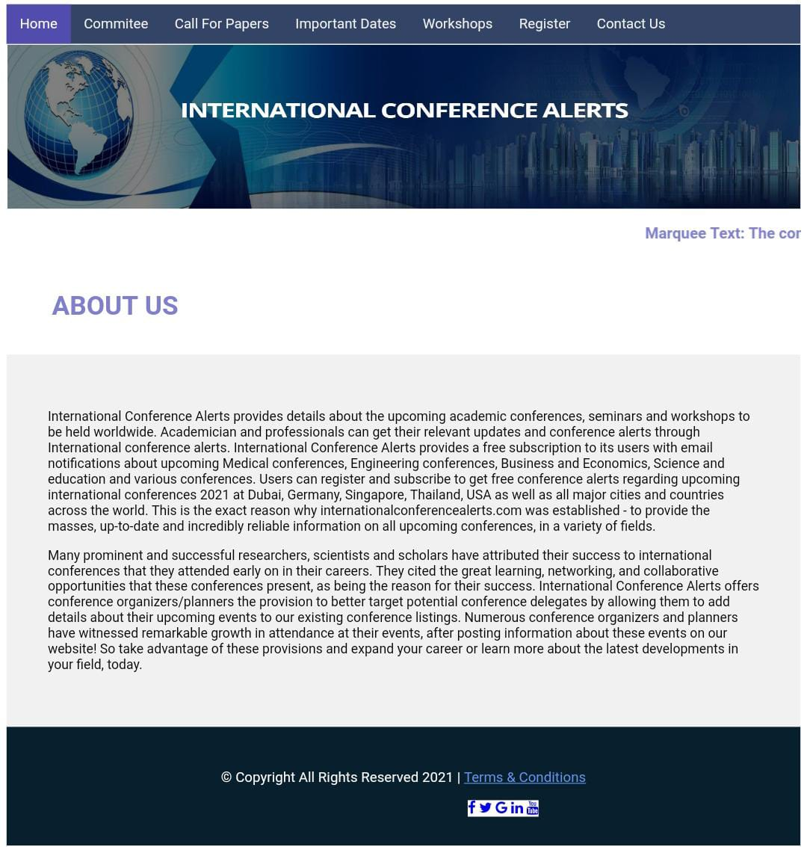

**COMMITEE PAGE:**

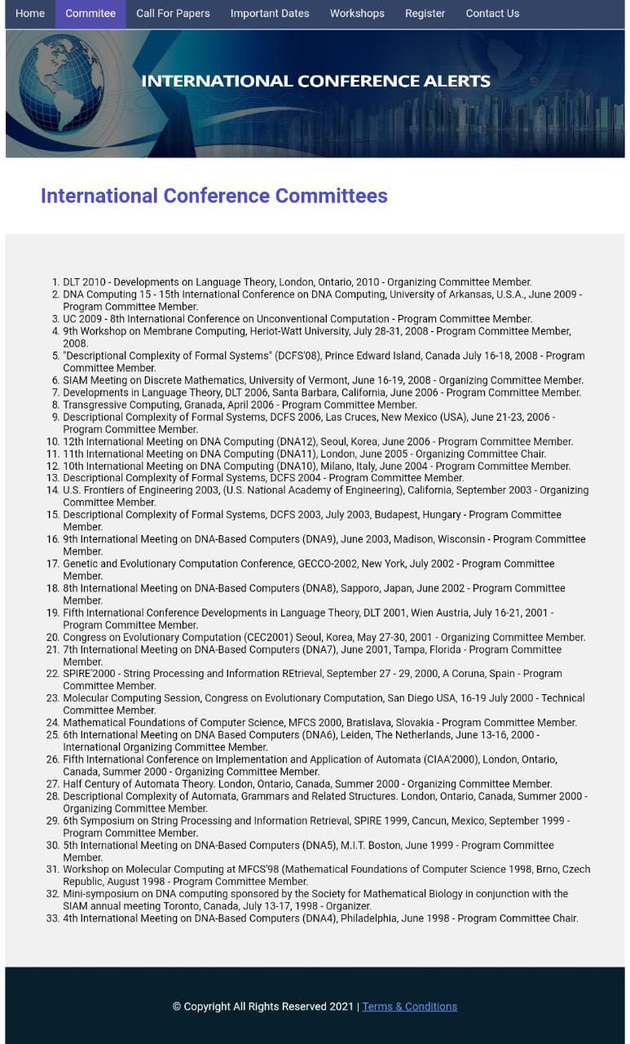

**CONFERENCE PAGE:**

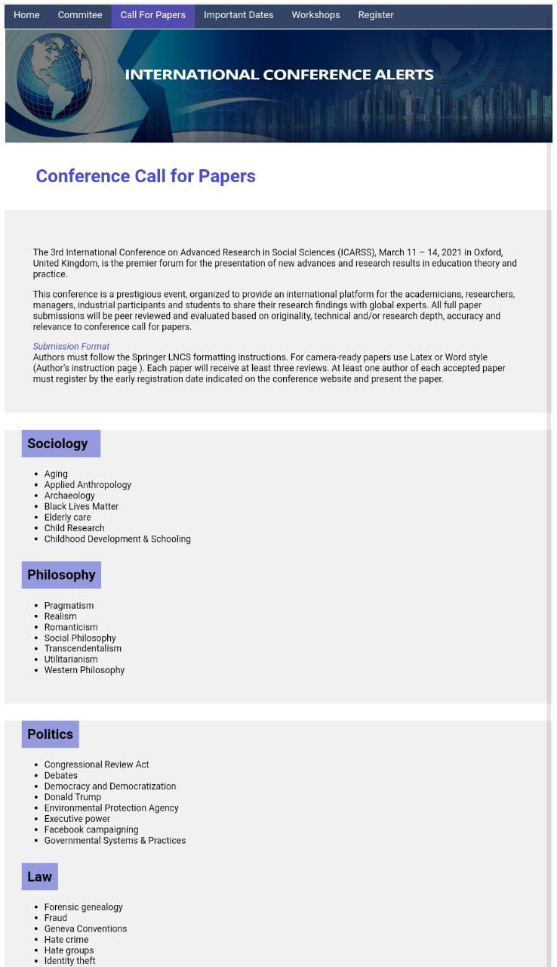

**DATES PAGE:  
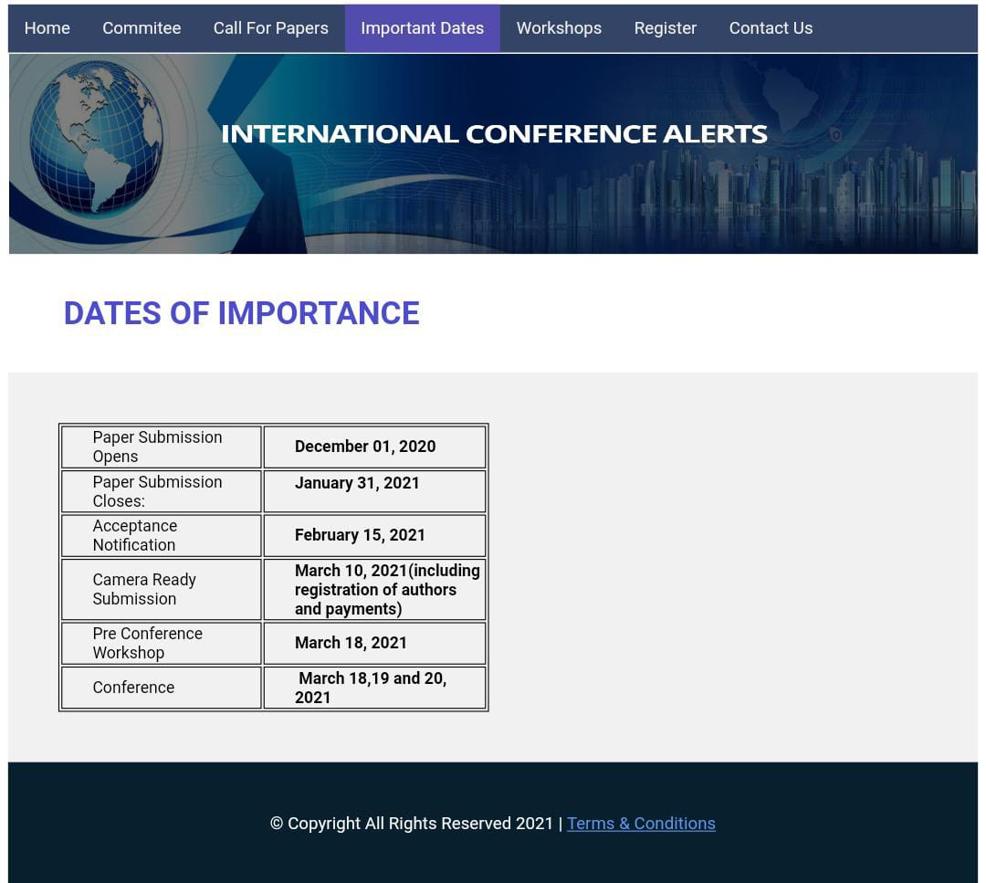**

**WORKSHOPS PAGE:**

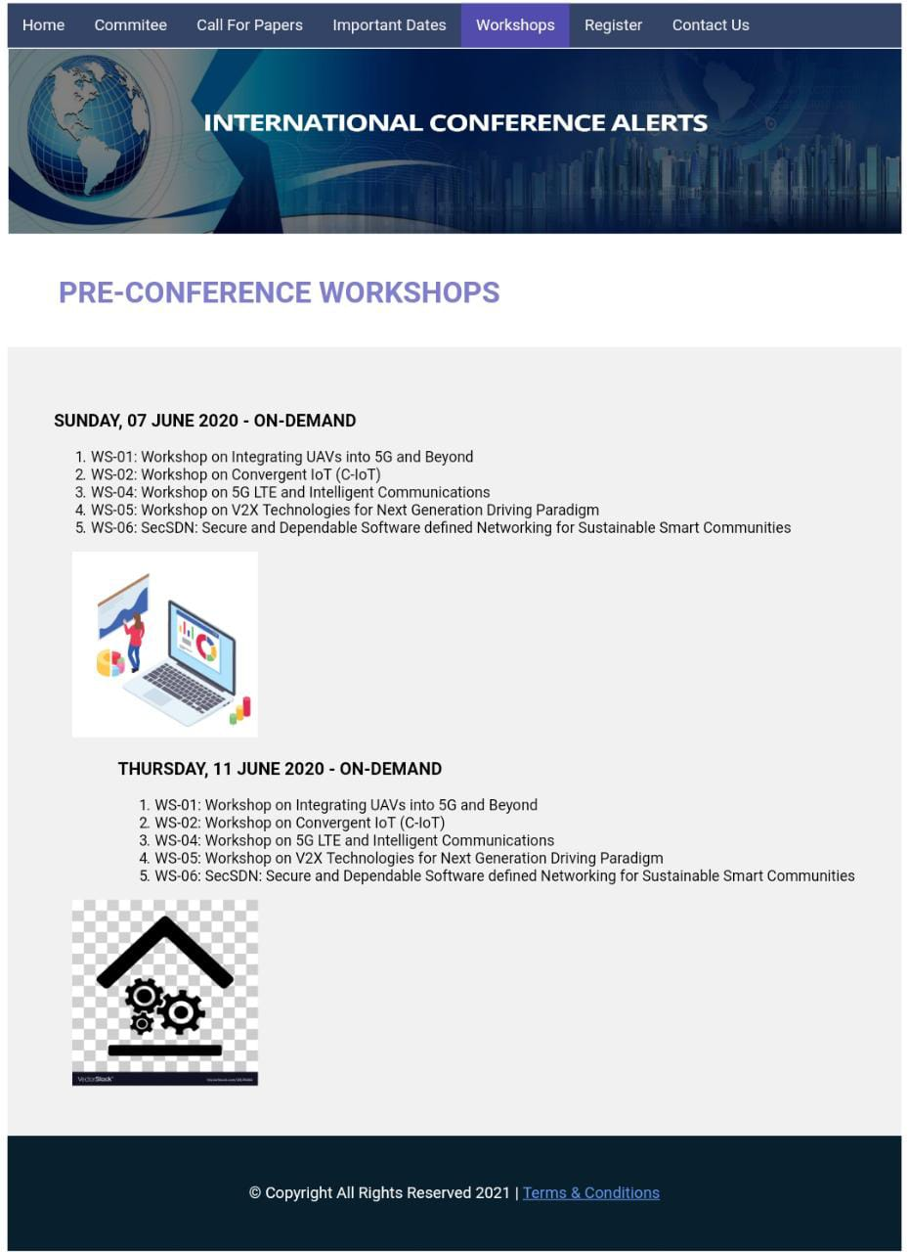

**REGISTER PAGE**

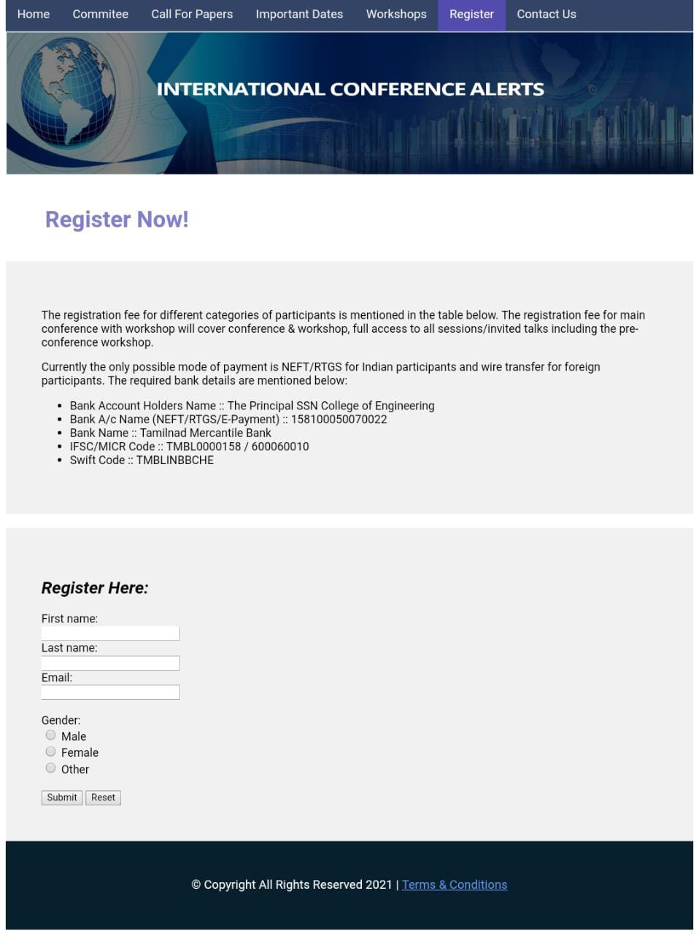

**CONTACT US PAGE:**

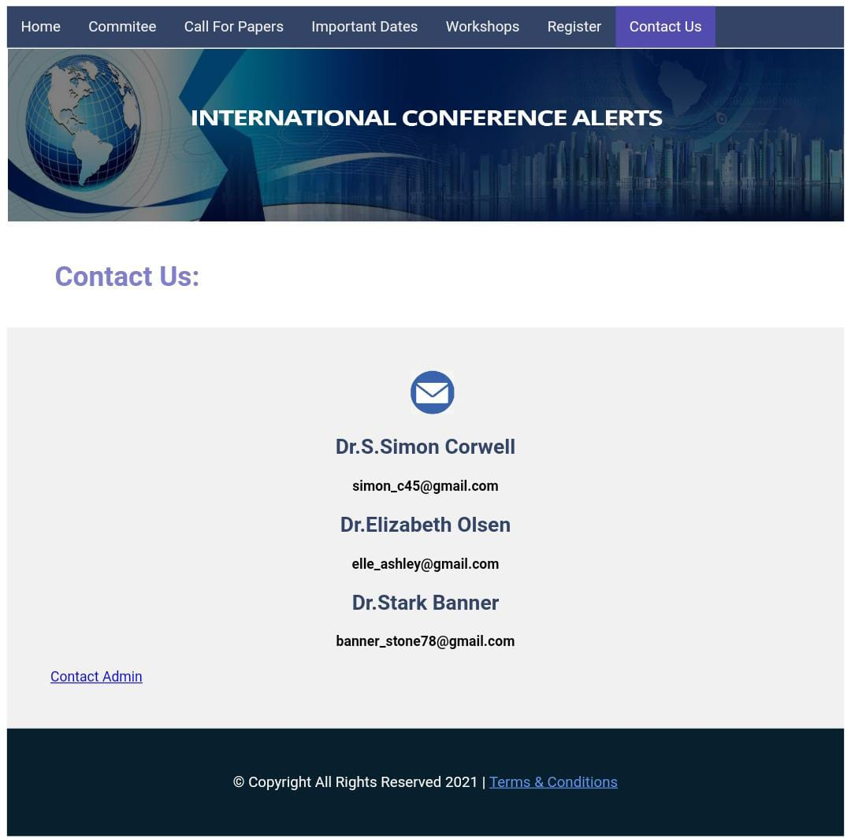

**LEARNING OUTCOME:**

* Learnt about the attributes for the HTML5 tags and used it in the experiment and the syntax of HTML5.
* Learnt how to create a simple web page and identify how to format text, adding web links using anchor tags and add images.
* Learnt to implement basic animation through marquee tag.
* Understood creating tables, basic forms and adding styles to my web pages.
* Learnt to demonstrate borders, backgrounds, and HTML semantic tags.
* Understood how to use text formatting tags like strong, emphasis, and strikethrough tags.
* Learnt the importance of making web pages accessible, well-formed and user friendly.